photo IMGCOVID-19 in London, Ontario: capturing the local experience

Document your experience during the COVID-19 pandemic
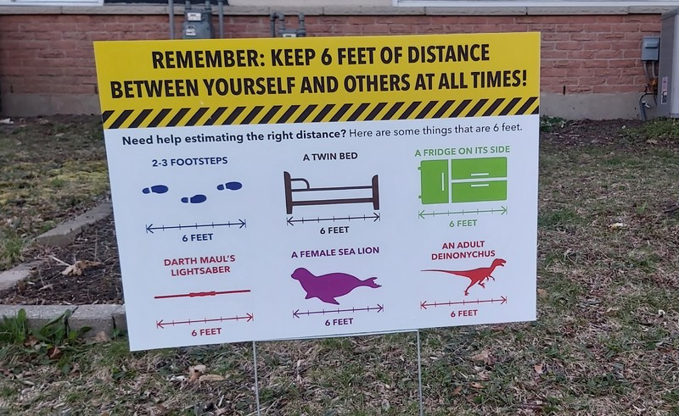
This is an unprecedented time in world history. Though COVID-19 is not the first world pandemic, it is the first time that people under quarantine have been able to share their experiences in real time through electronic communications. The material that we create and keep now will tell the story of the pandemic for future generations. We want to hear about your experiences whether it’s working at home, teaching your children, being an essential worker, trying to stay safe, feeling worried or afraid or anything else you may be experiencing.

Who can participate?
Anyone who lives, works or studies in London-Middlesex, Ontario, including Western University, businesses and organizations.

How can you participate?
- Write: Keep a journal, compose creative writing, and save correspondence
- Create art: Share images or recordings of your art compositions of any medium
- Share your experiences: Start a video blog or speak into a recorder
- Take photographs: Document your environment, community, and life in quarantine using photographs or video
- Upload records from your business: Document how it responded to the crisis by sharing social media graphics, signage, e-mail or mail correspondence, and business announcements, etc.
- Save your social media posts
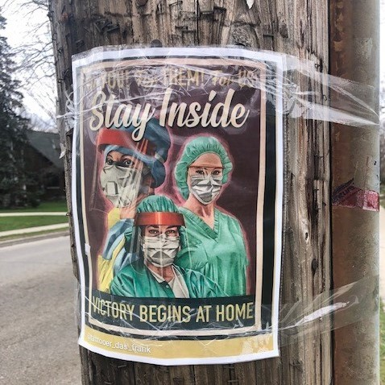

What will we do with your submissions?
- Electronic submissions will be stored digitally by Western Libraries Archives and Special Collections
- Submissions will be available on our website to anyone to view
- Future researchers will use the archive to understand what the pandemic was like for Londoners

How do I submit?
Use our electronic submission form.

https://verne.lib.uwo.ca/s/covid19/page/welcome?fbclid=IwAR2nP5mx6wEFIIYBDV6V5eXAN8VSJ_Q3QN6iwTbUBuCcp2xmhwqZmpm8F0k

https://verne.lib.uwo.ca/s/covid19/page/welcome

